University of Kent
May/June 2021

Examination Answer Booklet
Before starting this examination, you MUST enter your Examination Number above (double click); failure to provide this means your mark cannot be recorded and you may be awarded a 0 (zero) for this examination.
Re-save the answer booklet to include your exam number in the file name, using the following format: [your exam number] [module code] AnswerBooklet (e.g. 123456 XX123 AnswerBooklet).
Answer one question per page. You may add additional pages to this document if necessary.

Question Number | 1a
Add your answer below:
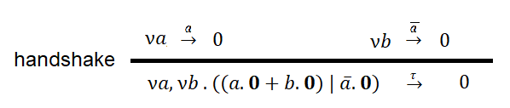
Question Number | 1b
Add your answer below:
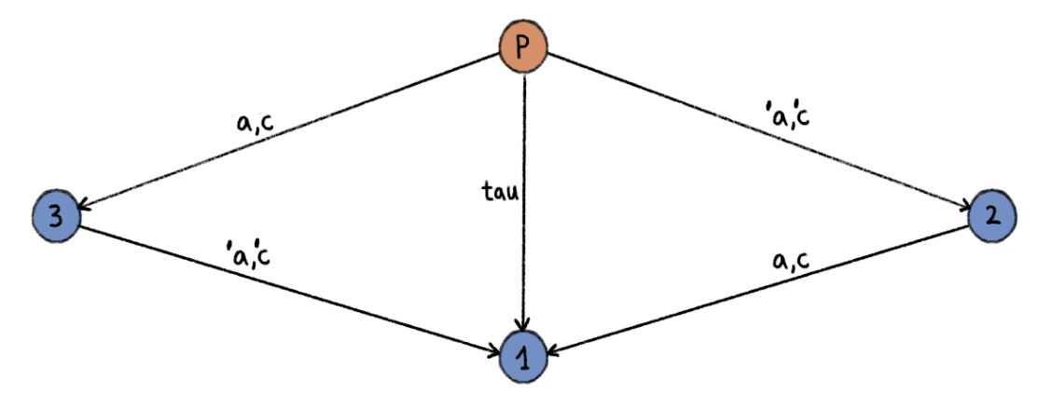
P = (′ a(bar).0 + ′ c(bar).0) | (a.0 + c.0)
1 = 0
2 = a.0 + c.0
3 = ′ a(bar).0 + ′ c(bar).0

Question Number | 1c
Add your answer below:
- Client = syn(bar).syn-ack.ack(bar).0

Question Number | 2a
Add your answer below:

Question Number | 2b
Add your answer below:
- Yes, because of compensation.

Question Number | 4a
Add your answer below:
- As it has no finite witness, due to the dates being unknown, it is a liveliness property. To make it a safety property, it can be modified to say: “Your goods will be dispatched on December 2nd, 2021”.

- As it has no finite witness, as there is no determination of when the lamp will change between the red and green pulses, it is a liveliness property. To make it a safety property, it can be modified to say: “The lamp will send an alternation every of “red” and “green” pulses every 5 seconds”.

Question Number | 4b
Add your answer below:

- {BA!ok, BA?ok, BA!money, BA?money}
{BA!ok, BA!money, BA?ok, BA?money}
{BA!ok, BA!money, BA?money, BA?ok}
{BA!ko, BA?ko}

- Fininte state machine R:
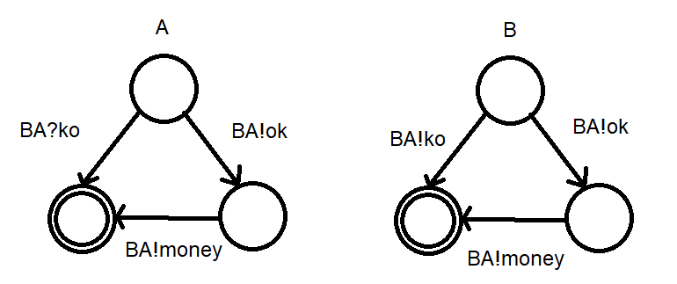

- There are no traces that is produced in R that cannot be found in M.

- {MSC1, MSC1} is realizable, because all traces of finite state machine R are found in finite state machine M.

